

Artificial Intelligence and Expert System Lab (CSE 404)

Department of CSE

Assignment No: 02

|  |  |
| --- | --- |
| Topic/Question: | Solve the following Maze game using A* algorithm.  Find the most cost-effective path to reach the final state from initial state A* Algorithm.  The agent will avoid the obstacles during traversing. |

Date of Submission: 4 Feb, 2021

|  |  |
| --- | --- |
| Submitted by | Submitted to |
| Name: Niamul Hasan  Id: **17201026**  Semester: 4.1  Section: A1 | Dr. Nasima Begum  Assistant Professor  Department of CSE  UAP |

|  |  |
| --- | --- |
| **Tools:** |  |
| 1. | Language: Python 3.8 (for coding) |
| 2. | IDE: visual studio code (text editor) |
| 3. | Drawio (for diagram drawing) |

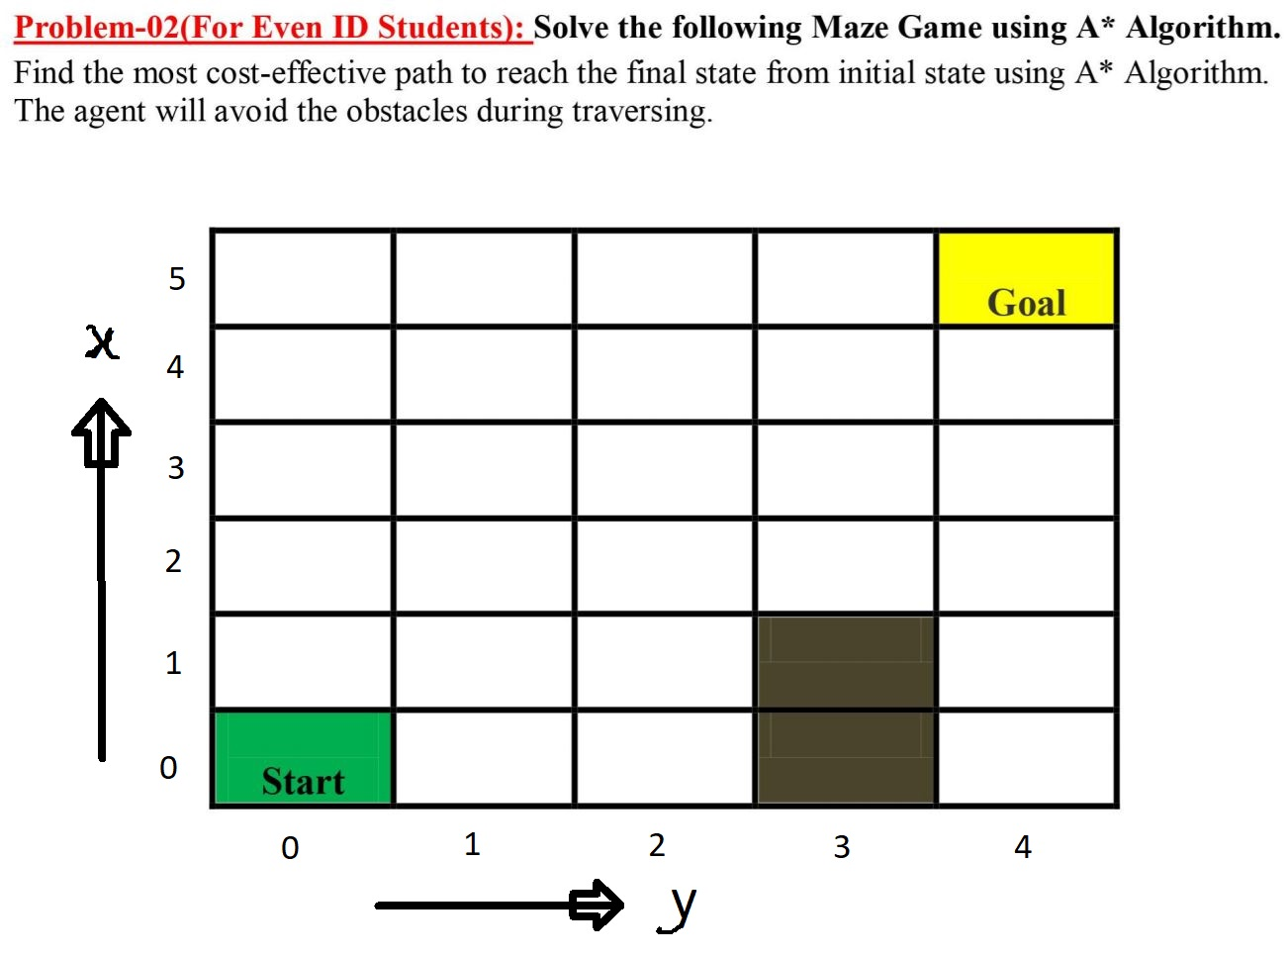

**For coding purpose, we are considering the maze in vertical mirror reverse way.**

|  |  |  |  |  |  |  |
| --- | --- | --- | --- | --- | --- | --- |
| y | | | | | | |
| x |  | 0 | 1 | 2 | 3 | 4 |
| 0 | **Start** |  |  |  |  |
| 1 |  |  |  |  |  |
| 2 |  |  |  |  |  |
| 3 |  |  |  |  |  |
| 4 |  |  |  |  |  |
| 5 |  |  |  |  | **Goal** |

**Objective/ Target:**

Here the objective is to move from start state to goal state and find the most cost-effective path to reach the final state from initial state by A* Algorithm.

**Tree:**

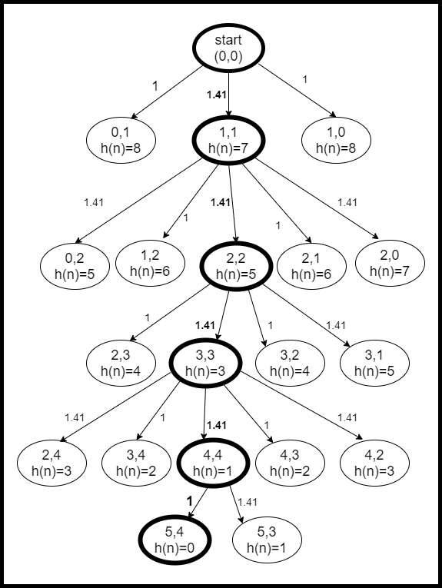

**Code:**

**Input:**

Here we are solving problem on a specific grid or maze. So, we can initialize our gride like this,

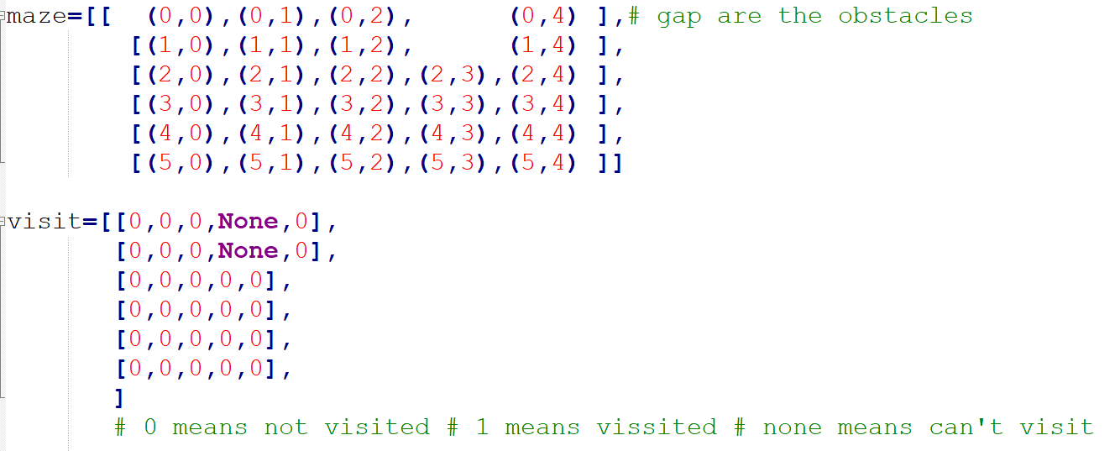

**Output:**

At first initialize the close fringe with start state: (0, 0)

f(n) of (0, 0) is : 9.00 = 0.00 + 9.00

neighbors of (0, 0) are [(0, 1), (1, 1), (1, 0)]

cost needed form (0, 0) to (0, 1) : 1.00

f(n) of (0, 1) is 9.00 = 1.00 + 8.00

cost needed form (0, 0) to (1, 1) : 1.41

f(n) of (1, 1) is 8.41 = 1.41 + 7.00

cost needed form (0, 0) to (1, 0) : 1.00

f(n) of (1, 0) is 9.00 = 1.00 + 8.00

now, the current position is (1, 1)

neighbors of (1, 1) are [(0, 2), (1, 2), (2, 2), (2, 1), (2, 0)]

cost needed form (1, 1) to (0, 2) : 1.41

f(n) of (0, 2) is 9.83 = 2.83 + 7.00

cost needed form (1, 1) to (1, 2) : 1.00

f(n) of (1, 2) is 8.41 = 2.41 + 6.00

cost needed form (1, 1) to (2, 2) : 1.41

f(n) of (2, 2) is 7.83 = 2.83 + 5.00

cost needed form (1, 1) to (2, 1) : 1.00

f(n) of (2, 1) is 8.41 = 2.41 + 6.00

cost needed form (1, 1) to (2, 0) : 1.41

f(n) of (2, 0) is 9.83 = 2.83 + 7.00

now, the current position is (2, 2)

neighbors of (2, 2) are [(2, 3), (3, 3), (3, 2), (3, 1)]

cost needed form (2, 2) to (2, 3) : 1.00

f(n) of (2, 3) is 7.83 = 3.83 + 4.00

cost needed form (2, 2) to (3, 3) : 1.41

f(n) of (3, 3) is 7.24 = 4.24 + 3.00

cost needed form (2, 2) to (3, 2) : 1.00

f(n) of (3, 2) is 7.83 = 3.83 + 4.00

cost needed form (2, 2) to (3, 1) : 1.41

f(n) of (3, 1) is 9.24 = 4.24 + 5.00

now, the current position is (3, 3)

neighbors of (3, 3) are [(2, 4), (3, 4), (4, 4), (4, 3), (4, 2)]

cost needed form (3, 3) to (2, 4) : 1.41

f(n) of (2, 4) is 8.66 = 5.66 + 3.00

cost needed form (3, 3) to (3, 4) : 1.00

f(n) of (3, 4) is 7.24 = 5.24 + 2.00

cost needed form (3, 3) to (4, 4) : 1.41

f(n) of (4, 4) is 6.66 = 5.66 + 1.00

cost needed form (3, 3) to (4, 3) : 1.00

f(n) of (4, 3) is 7.24 = 5.24 + 2.00

cost needed form (3, 3) to (4, 2) : 1.41

f(n) of (4, 2) is 8.66 = 5.66 + 3.00

now, the current position is (4, 4)

cost needed form (4, 4) to (5, 4) : 1.00

f(n) of (5, 4) is 6.66 = 6.66 + 0.00

cost needed form (4, 4) to (5, 3) : 1.41

f(n) of (5, 3) is 8.07 = 7.07 + 1.00

now, the current position is (5, 4)

Now, we reached to goal (5, 4)

f(n) of (5, 4) is : 6.66 = 6.66 + 0.00

Now, the cost effective path to reach the final state from initial state is:

(0, 0) --> 1.41 --> (1, 1) --> 2.83 --> (2, 2) --> 4.24 --> (3, 3) --> 5.66 --> (4, 4) --> 6.66 --> (5, 4)

Total cost: 6.66